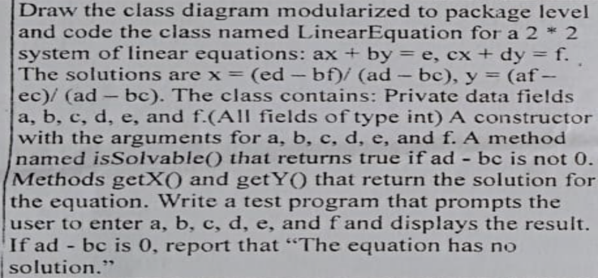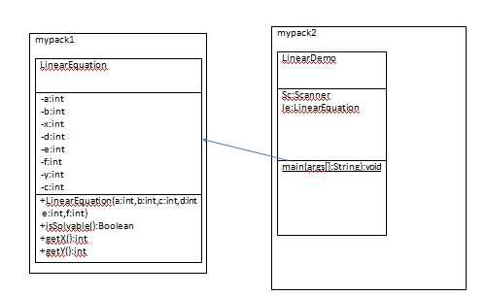
package mypack1;

public class LinearEquation {
private int a,b,c,d,e,f,x,y;
publicLinearEquation(inta,intb,intc,intd,inte,intf)
{
this.a=a;
this.b=b;
this.c=c;
this.d=d;
this.e=e;
this.f=f;
}
publicboolean isSolvable()
{
intresult;
result=(this.a*this.d)-(this.b*this.c);
if(result==0)
returnfalse;
else
returntrue;
}
public int getX()
{
this.x=(e*d-b*f)/(a*d-b*c);
returnthis.x;
}
public int getY()
{
this.y=(a*f-e*c)/(a*d-b*c);
returnthis.y;
}
}

package mypack2;
import mypack1.LinearEquation;
import java.util.Scanner;
publicclass LinearDemo {
publicstaticvoid main(String args[])
{
Scanner sc=new Scanner(System.in);
inta,b,c,d,e,f;
System.out.println("enter a,b,c,d,e,f");
a=sc.nextInt();
b=sc.nextInt();
c=sc.nextInt();
d=sc.nextInt();
e=sc.nextInt();
f=sc.nextInt();
LinearEquation le=new LinearEquation(a,b,c,d,e,f);
if(le.isSolvable())
{
System.out.println("x="+le.getX()+"y="+le.getY());
}
else
System.out.println("the equation has no solution");

}

}

